SRM with 8/6 magnetic system topology for electric drive  
of mine battery electric locomotives: Design and Modelling

V N Antipov, A D Grozov and A V Ivanova

Institute of Silicate Chemistry RAS, 2, Makarova emb., Saint Petersburg, 199034, Russia

E-mail: bht@mail.ru

**Abstract.** The paper deals with the development and simulation results of the switched reluctance motor for electric drive of mine battery electric locomotives instead of the DRT-14 DC motor. The switched reluctance motor parameters are obtained based on numerical calculation of the magnetic field by QuickField program and are embedded in MATLAB/Simulink model of a switched reluctance motor created for 8/6 magnetic system configuration. SRM-14-615 has the mechanical characteristics as DC motor DRT-14 and meets the required operating modes as part of the AM8D mine battery electric locomotive. Also two types of models using methods and techniques of the artificial intelligence theory are presented: a model with a fuzzy control system in the Fuzzy Logic Toolbox package and a model with a neural network control system in the Neural Network Toolbox package.

1. Introduction

Switched Reluctance Motor (SRM) drives have been used for many years in applications, where design simplicity was primary important. The theory of a rotating magnetic field and well-developed methods for calculation of rotating electric machines are not applicable to SRMs. The literature notes the complexity of solving the problem of SRM with high technical indicators creating. Numerous studies have almost overcome this drawback [1]‑[4].

We believe the SRM development has to be based on the principles of block-modular motor design. It means that a basic industry-developed motor prototype is selected and all necessary components and parts (housing, shaft, bearings, shields, etc.) are saved, with the exception of the developed stator coils, stator and rotor packages, as well as a small shaft revision. Thus, in block-modular motor design, the constraints are the outer diameter of the stator package and the inner diameter of the rotor package, the dimensions of which must be saved when designing the stator and rotor iron sheets. The principles of block-modular motor design ensure a minimum of production and financial costs [5].

The SRM design procedure differs significantly from the traditional one and includes three interrelated design stages [5], [6]. The authors have developed their own algorithms and calculation programs based on EXCEL, QuickField, and MATLAB technologies for each of the design stages.

The inclusion in the design procedure of typical mathematical blocks of visually-oriented modeling MATLAB matrix system with the Simulink and SimPowerSystems extension packages opens up additional opportunities for effective design [6]‑[9].

This paper presents the results of a study in the Matlab/Simulink environment of a four-phase Switched Reluctance motor with the topology of the magnetic system 8/6 for a mine battery electric locomotive. For study of this motor topology three Simulation block diagrams have been created for controlling the speed of rotation, battery including those created with methods and techniques of the theory of artificial intelligence. The created models were verified in various modes of a wide range of ×motor speed control.

1. Materials and methods

The electric motor SRM-14-615 (14 kW, 145 V, 615 min-1) is designed for electric drive of mine battery electric locomotives AM8D and 2×AM8D with a coupling weight of 8 tons and meets the requirements for the currently used electric motor DRT-14 (14 kW, 130 V, 615/1845 rpm). The prototype is designed and founded on the principles of block-modular motor design based on DC motor 4PF200L. The *n*-sided frame of electric motor 4PF200 is used as a stator SRM-14-615 and the axial length of the rotor package is limited to 200 mm. The transition to an n-face frame allows you to effectively implement a variant of a four-phase electric motor *m*=4, *Ns*=8, *Nr*=6. The width of the stator (rotor) tooth in the angular version is considered optimal – 20.3 (23.7) degrees [6]. To select the rotor diameter, calculations were performed for four of its values in the range of 210–261 mm. The limiting factor when choosing the diameter is the current density in the winding, which for the degree of motor protection of IP54 should not be higher than 2.5 A/mm2.

For the prototype, new packages of stator poles, a package of the rotor and stator coils were made, the shaft, bearing shields, bearings, labyrinth seals and other necessary parts were preserved from the 4PF200 DC motor in addition to the charge bed.

The switched reluctance motor SRM-14-615 is the totally enclosed air over (TEAO), 4 phase machine with 8/6 magnetic system topology. It has the next main data:

External stator diameter, mm 396

Rotor diameter, mm 261

Stator package length, mm 215

Air gap, mm 1.0

Coil turns number 23.5

Phase inductance, mH 29.0

Torque at *I*=*In*, Nm 5.5

Torque at *I*=2*In*, Nm 16.3

The second design stage it is calculating (using the QuickField program) the motor electromagnetic field for different current values at the agreed and mismatched positions of the rotor and the stator and also determining the flux linkage dependences on the phase current at different rotor positions.

1. Investigation results

Previously, the authors created the models in MATLAB/Simulink environment and investigated SRM with 6/4 and 12/8 magnetic system topology [5-6]. The Simulink model structure is the same for both topologies, so for creating Simulation SRM block diagram with 8/6 magnetic system topology it is necessary to add the fourth phase and to implement the differences by changing *Look-Up Table* blocks and the MATLAB *Function task* blocks.

The model of speed control developed in the MATLAB/Simulink environment with current limitation is shown in figure 1 where one phase is shown in detail, and the other three are represented by Subsystem blocks. The running motor speed value ω obtained after solving the equation of motion, is fed to the input of MATLAB *Function* 2 with *Integrator* 3.The specified parameters are: voltage *U*, current limit *Iref*, load torque *Tload*, moment of inertia *J*, switching on θ*on* and off θ*off*angles. The simulation determines the speed ω.

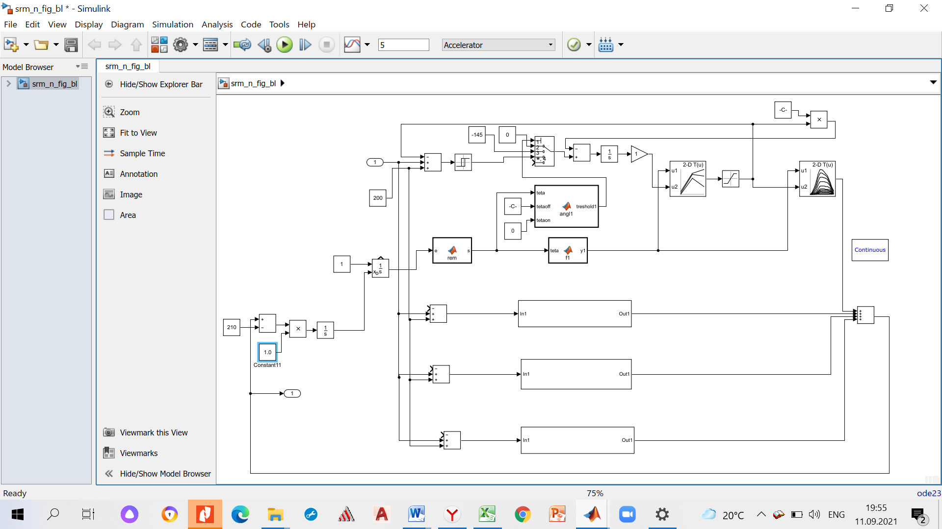

**Figure 1.** Simulation SRM block diagram for speed control with current limitation.

In the *Look-Up Table* block, the phase current data is recorded in the form of a 2-dimensional table, depending on the discrete values of flux linkage and misalignment angles *i*=*f*(ψ,θ). Flux linkage data obtained by finite element method (2-D FEM) in the form of a 2-dimensional table depending on the discrete values of phase currents and misalignment angles ψ=*f*(*i*,θ) have been converted into the dependences *i*=*f*(ψ,θ) by means of MATLAB by creating a special *m*-file. Current dependences on flux linkage at different rotor positions θ for SRM-14-615 are represented in figure 2.



**Figure 2.** Current dependences on flux linkage at different rotor positions θ for SRM-14-615.

Flux linkages are obtained by two dimensional (2-D FEM) models for misalignment angles of 0–π/6° with π/90 interval. In the *Look-Up Table* 1 blocks, the torque data are recorded depending on the phase current and the misalignment angle. The problem is also solved by MATLAB *m*-file creating, in which the coenergy and its gradient have been determined. Torque dependences on currents at different rotor positions θ for SRM-14-615 are represented in figure 3.



**Figure 3**. Torque dependences on currents at different rotor positions θ for SRM-14-615.

The MATLAB *Function* 2 block has to use the *rem* function (*remainder after division*) to convert a continuous rotor angle function into a *rotation angle* function between 0 to π/3 for topology 8/6. The MATLAB *Function* 7 block the created *m*-file is used. The rotation angle values for each phase are converted from the range [0‑π/3] into the range [0–π/6] for topology 8/6., i.e. for the ranges for which the two-dimensional tables of the *Look-Up Table* and *Look-Up Table* 1 blocks are written.

The MATLAB *Function* block uses an *m*-file for each phase to switch signals in the multiport switch according to expression:

 (1)

where θ is the misalignment angle of the rotor and stator position, *uj* is the phase voltage depending on the angle θ.

For the further analysis, phase current, flux linkage, and torque data are stored in the workspace using *Simout* blocks. Figure 4 contains the example of data received on the *Scope oscilloscope* screens during simulation.



(a)



(b)



(c)

**Figure 4.** Simulation data on screens oscilloscopes (mode Δ=π/8, *Irms*=71 A, *Tel*=215.6 Nm, ω=68.6 rad/c): phase current (a), electromagnetic torque (b), motor speed (c).

The mine battery electric locomotive AM8D is equipped with two DC motors DPT-14, which can be schematically switched on in parallel or in series. The simulation was performed for a voltage of 145 and 72.5 V to take into account both switching options. The results are presented in table 1 and figure 5.

|  |  |  |  |
| --- | --- | --- | --- |
| **Table 1.** SRM-14-615 motor speed simulation on the reference model. | | | |
| *Iref*, A | *N*, rpm | *Irms*, A | *Tel*, Nm |
| *U*=145.0 V | | | |
| 200 | 1108 | 27.7 | 32.9 |
| 200 | 927 | 36.7 | 50.5 |
| 200 | 701 | 53.8 | 127.4 |
| 200 | 655 | 71.1 | 215.6 |
| *U*=72.5 V | | | |
| 200 | 676 | 25.5 | 21.4 |
| 200 | 575 | 29.6 | 28.7 |
| 200 | 473 | 39.1 | 48.7 |
| 200 | 386 | 44.6 | 100.3 |

Figure 5 also shows the calculated points of the mechanical characteristics of the DRT-14 motor. The comparison shows that the designed motor SRM-14-615 meets the required operating modes as part of the AM8D mine battery electric locomotive.



**Figure 5**. SRM-14-615 motor speed simulation on the reference model: 1 ‑ *U*=145.0 V, 2 ‑ *U*=72.5 V.

It is possible to study the switched reluctance motors of using artificial intelligence methods and techniques [10]‑[14].

The basis for such development SRM-14-615 with the magnetic system topology 8/6 is the new created model in the MATLAB/Simulink environment for speed control with current limitation (figure 1).

A model with a fuzzy control system is developed in the Fuzzy Logic Toolbox package, and a model with a neural network control system is developed in the Neural Network Toolbox package. First of all in Simulation SRM block diagram for speed control with current limitation (figure 1) has been added fragment figure 6, a to create simulation SRM block diagram for speed control with a fuzzy logic, or fragment figure 6, b to create simulation SRM block diagram for speed control with the neural network. The connection points of the fragments are shown in figure 1 and figure 6.

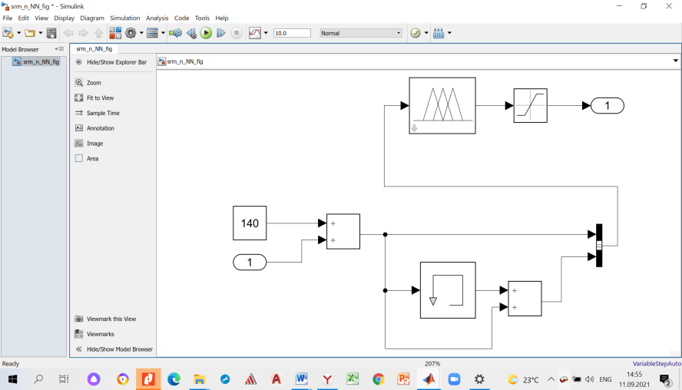 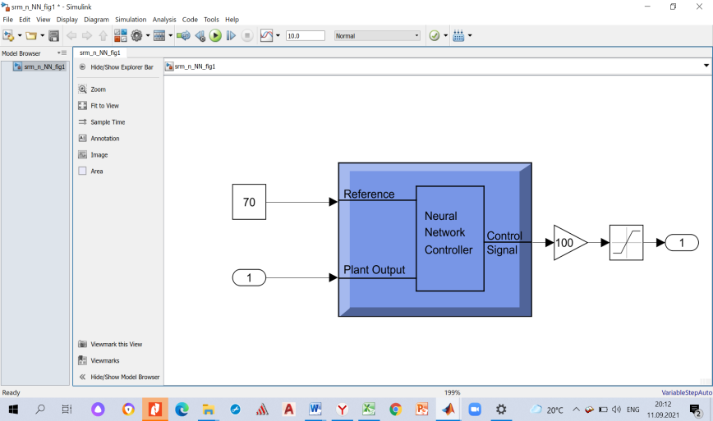

(a) (b)

**Figure 6.** Fragments for creating simulation SRM block diagram for speed control with a fuzzy logic (a) and with the neural network (b).

The model with a fuzzy logic-based control system is developed interactively in the Fuzzy Logic Toolbox package. A fuzzy inference system of the Sugeno type has two input variables – the angular rotation frequency ω and its deviation from the specified one Δω=ω–ω*ref* is selected.

Each variable is characterized by 5 membership functions, the type of which can be selected from the functions built into the editor. For both variables, triangular functions of the type *trimf* are selected (S2, S1, CE, B1, B2). For membership functions 25 rules of the fuzzy inference system are written in the form: “If (*x*1 is S2) and (x2 is S2) then (y is S2)”. The adopted rules are presented in table 2.

|  |  |  |  |  |  |
| --- | --- | --- | --- | --- | --- |
| **Table 2**. 25 rules of the fuzzy inference system. | | | | | |
| ω / Δω | S2 | S1 | CE | B1 | B2 |
| S2 | S2 | S2 | S2 | S1 | CE |
| S1 | S2 | S1 | S1 | CE | B1 |
| CE | S2 | S1 | CE | B1 | B2 |
| B1 | S1 | CE | B1 | B1 | B2 |
| B2 | CE | B1 | B2 | B2 | B2 |

The method of algebraic product (*prod*) is chosen for performing logical conjunction under fuzzy rules, and the method of algebraic sum (*probor*) is chosen for performing logical disjunction. To make a logical conclusion in each of the fuzzy rules, the minimum value (*min*) method is selected, and for aggregating values, the maximum value (*max*) method is selected. To perform de-fuzzification of output variables in the Sugeno fuzzy inference system, the weighted average method (*wtaver*) is adopted. According to the selected conditions, the *srm_nFL_86* file is created, which is written to the Fuzzy logic controller with Ruleviever Simulink block of the model shown in figure 6, (a).

The model with the neural network control system is developed in the Neural Network Toolbox package. The controller based on the reference model – Model References Controller ‑ is selected as the control system (figure 6, b). The Simulink file *srm_n*_86 of motor speed control by current limitation is selected as the reference model of the SRM-14-615 for the neural network (figure 1). As a training example, the *base*86.mat file is created, which records the dependence of the angular speed of rotation on the time ω=*f*(*t*), obtained by calculating the reference model *srm_nNN_*86 for the speed of rotation ω*ref=6*8.6 rad/s and containing 10620 values.

The Model References Control window also permits to select data: the number of hidden layers – 10, delayed inputs of the reference model – 2, delayed outputs of the controller – 1, delayed outputs of the object – 2.

To identify the object model (*Plant indetification*), the following parameters are set: the number of hidden layers – 10, delayed inputs of the object model – 2, delayed outputs of the object model – 2; the Simulink file *srm_nNN_86* which contains the controller (figure 6, b), and the training example file *base86.mat* are entered; the number of variables (10620), minimum (0) and maximum (ω*ref*) values, maximum (0.001) and minimum (0.0001) interval values. When training the network for the specified number of iterations and training the controller, we get the final acceptance of the Simulink data and then the file *srm_nNN*_86is ready for modeling.

Results of SRM-14-615 motor speed simulation on the reference model for the mode with the voltages U=145°V and 72.5°V are shown in figure 5. The same modes are modeled on the created models. For comparison, the data are summarized in table 3.

|  |  |  |  |  |  |  |  |  |  |  |  |
| --- | --- | --- | --- | --- | --- | --- | --- | --- | --- | --- | --- |
| **Table 3**. Comparison of SRM-14-615 simulation results for different control algorithms | | | | | | | | | | | |
| Reference model | | | | Model with a fuzzy logic, figure 6, a | | | | Model with the neural network figure 6, b | | | |
| *Irms*, А | Ω, rad/s | *Tmean*, Nm | *KpT*, % | *Irms*, А | ω, rad/s | *Tmean*, Nm | *KpT*, % | *Irms*, А | ω, rad/s | *Tmean*, Nm | *KpT*, % |
| *U*=145.0 V | | | | | | | | | | | |
| 71.1 | 68.6 | 215.6 | 25.6 | 81.7 | 68.6 | 213.7 | 24 | 80.4 | 68.4 | 221.4 | 23.4 |
| 31.1 | 116 | 32.9 | 46.5 | 34.5 | 100.4 | 44.8 | 42.4 | 37.5 | 114.1 | 32.6 | 48.2 |
| U=72.5 V | | | | | | | | | | | |
| 44.6 | 40.4 | 100.3 | 27.8 | 53.1 | 40.9 | 99.25 | 29.4 | 53.3 | 40.3 | 98.1 | 32.4 |
| 25.5 | 70.7 | 21.4 | 48.6 | 26.5 | 71.0 | 21.3 | 48.5 | 27.4 | 69.7 | 24.3 | 47.6 |

The comparison was carried out according to the main parameters of the studied mode – the effective value of the phase current *Irms*, the angular rotation frequency ω, the average value of the rotating electromagnetic torque *Tmean*, the torque ripple coefficient *KpT*. It should be noted, that there is a minimal difference in the angular frequency of rotation (1.6%), a small difference in the torque magnitude (3.6%) and its ripple coefficient, and the largest difference in the magnitude of the RMS current (3.9–19.5%).

1. Conclusion

Switched reluctance motor SRM-14-615 based on the principles of block-modular motor design is proposed for electric drive of mine battery electric locomotives instead of the DRT-14 DC motor. The study of the SRM-14-615 operating modes in MATLAB/Simulink environment was conducted on a model created for the 8/6 magnetic system configuration. The model makes it possible to improve the design procedure, rationally select the control parameters (*Iref*, θ*on*, θ*off*, ω, *Mload*) and get the dynamics of the main parameters changes in different motor modes. SRM-14-615 has the mechanical characteristics as DC motor DRT-14 and meets the required operating modes as part of the AM8D mine battery electric locomotive.

Also two types of models using methods and techniques of the artificial intelligence theory are presented: a model with a fuzzy control system in the Fuzzy Logic Toolbox package and a model with a neural network control system in the Neural Network Toolbox package. Based on the results of verification of the created models in various modes it has been found that the selected methods and characteristics of artificial intelligence controllers allow us to successfully simulate the Switched Reluctance drive. As in Fuzzy Logic Toolbox package, so in Neural Network Toolbox package only one training example file can be used for a wide range of motor speed.

Acknowledgements

The work has been carried out with the financial support of the RFBR grant, project No. 20-08-00386.

References

1. Miller T J E 2002 *IEEE Trans. on Industrial Electronics* **49(1)** 15‑27
2. Pratapgiri S, Polaki P and Narsimha V 2012 *World J. of Modelling and Simulation* **8(3)** 185‑193
3. *Electronic Control of Switched Reluctance Machines* (ser. Newnes Power Engineering Series) 2001, ed J E Miller (Oxford, U.K.: Newnes)
4. Krishnan R 2001 *Switched reluctance motor drive* (CRC Press)
5. Antipov V N, Grozov A D and Ivanova A V 2016 *Elektrichestvo* **10** 45–52
6. Antipov V N, Grozov A D and Ivanova A V 2020 *Proc. of the Int. Conf. Electr. Mach*. *ICEM 2020* 1820–1825
7. Soares F and Costa Blanco P J 2001 *IEEE Trans. Aerospace and Electronic systems* **37(3)** 989‑1009
8. Chancharoensook P and Rahman M F 2002 *Proc. IEEE Annual Conf. of the Industrial Electronics Society*, **1** 491‑496
9. Matveev A, Kuzmichev V, Nilssen R and Undeland T 2003 *Proc. of the European Conf. on Power Electronics and Appl.* 1‑10
10. Tanaka K and Wang H O 2001 *Fuzzy Control Systems Design and Analysis: A Linear Matrix Inequality Approach* (New York: John Wiley & Sons, Inc.)
11. Wadnerkar V S, Bhaskar M M, Das T R and RajKumar A D 2010 *J. of Electrical Engineering & Technology* **5(2)** 276–281
12. Karakas E and Vardarbasi S 2007 *Sadhana* **32(5)** 587–596
13. Pushparajesh V, Balamurugan M and Ramaiah N 2019 *SSRN Electronic J.* DOI: 10.2139/ssrn.3371369
14. Li C, Wang G, Li Y and Xu A 2018 *Automatika* **59(1)** 24–34